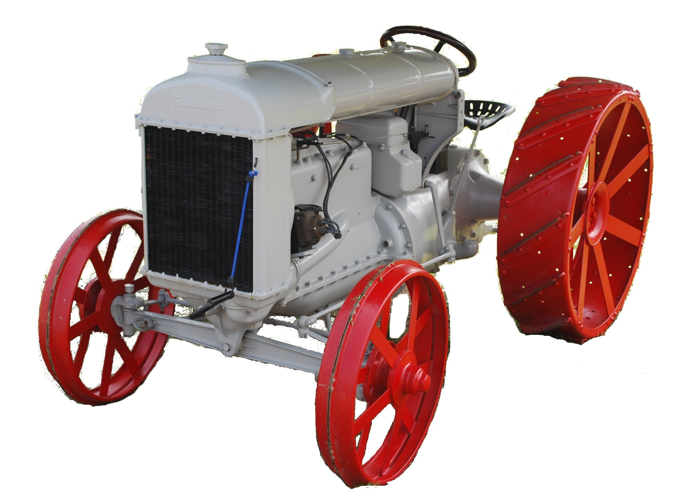
F O O T H I L L S

ANTIQUE POWER ASSOCIATION
ESTABLISHED 2003

October 2017
Dear Members,
October is here – the time of many shows, festivals, and autumn events. The month started with a bang and it will continue all month.
If you missed the club outing (several did because of the rain), you missed a good meal and some good fellowship. If you were unable to attend, you really missed out. A special thanks to Glen Sigmon for being a superb host and having graciously invited us to enjoy his beautiful farm and collection. God bless you, Glenn.

- We continue to pray for those of our members, families, and friends who have special needs. Remember also to pray for our country and for those who are cleaning up from the recent hurricanes & storms.

  - Reba Reinhardt
  - Jacqueline Hilliard
  - Ann Little
  - Henry Burns
  - Carl Switzer (in FL)
  - Brandon Bowman
  - Philip Spencer
  - Tammy Hoyle
  - Vee Williams
  - Lorna Sheets
  - Billie Sue Goforth
  - Steve Hefner
  - Vicki Hastings
  - Ira & Ann Cline
  - James Grant
  - Kelly Blanton
  - Rev. Bobby Langston
  - Don Johnson
  - Carl Porter
  - Jane Abernathy
  - Kay Nash

- The Swap Meet on Sept. 16 went very well with a headcount of over 160. An increase in the number of vendors indicates we are growing. We have some ideas to make the event even bigger next year, so stay tuned. Better yet, we’d like to hear your ideas, so plan on being a part of the planning committee in 2018.

- The Building Fund raffle also went very well. We were blessed to have sold all 300 tickets about three weeks prior to the event so there was not a last minute rush to push ticket sales. We had approximately 275 people attend the event where attendees enjoyed a wonderful BBQ meal prepared by club members. A special thanks goes out to the cooks, servers and all others involved in planning, organizing, food preparation, set up, clean up and ticket sales. We would also like to give a special thanks to all the ladies who prepared desserts that finished off the meal.

  - The final tally on the proceeds from both the Swap Meet and the Raffle has yet to be counted. There are a couple bills outstanding. We will have the total at the December regular meeting.
  - Congratulations are in order for the following winners of the drawings: Sandy Miller, Tom Lail, Barney Reid, Richard Hollar, Stanley Icenhour, David Reese, and the trio of Jimmy Huffman, Donald Robinson, and Mark Bland who spilt the grand prize.

- Elections were held for the upcoming 2018 year. The existing slate of officers was nominated, each in turn, and each was re-elected unanimously.

  - Kevin Black – President
  - Wilson Sigmon – Vice-President
  - Kermit Nash – Treasurer
  - David Setzer – Secretary
  - Teddy Hefner – Show Committee Chairman
  - BJ Moretz – Show Committee asst. chairman
  - Butch McIntyre – Swap Meet chairman
  - Teddy Hefner, Tim Hollar, and Butch McIntyre – Board of Directors (2-year term).

-- --- --- THE CLASSIFIEDS --- --- ---

Is there anything you would like to sell or are you looking for something special? List it here.
(Item listings will run for 3 months before expiring. Let us know when an item is sold or bought.)

FOR SALE

Cultivators for International 140; Glenn Bostian 828-459-7412. (1709)

AC CA wide front older repaint $2000; AC 200 $5000; AC D-19 Wide Front diesel $4750;
AC IB $1650; AC I400 with Loader $3650 – Wilson Sigmon (home) 828-256-2176, (cell) 828-320-1419 . (1709)

--- --- --- UP-COMING EVENTS --- --- ---

Oct 13-15 Dallas Cotton Ginning Days
Oct 20-22 Charlotte Stumptown Tractor Show
Oct 19-20 Arden Western NC Harvest Days
Oct 21 Taylorsville Apple Festival
Oct 28 Newton “Spooktacular” [need wagons]
Nov 2 Sig’s monthly meeting
Nov 4 Mt Grove Bap. Ch HarvestFest
Nov 11 Catawba Veteran’s Day parade
Nov 23 Thanksgiving Day
Nov 26 Maiden Maiden Christmas parade
Dec 2 Claremont Claremont Christmas parade
Dec 2 Taylorsville Taylorsville Christmas parade

☺ ☺ !!!!! HAPPY BIRTHDAY !!!!! ☺ ☺


October Birthdays

1 – Doug Carrigan
4 – Richard Hudson
5 – Tim Hollar
7 – David Setzer

7 – Jerry Teague
8 – Bob Huffman
13 – Jeff Bowman
17 – Todd Painter
18 – Johnny Parsons
19 – Eugene Lefeber
19 – Tyler Lutz
26 – Joseph Cline
28 – Richard Drum

November Birthdays

3- Jerry Matthews
3 – Marshall Wray

4 – Howard Williams
5 – Cody Hastings
5 – Barry Propst
6 – George Simmons
7 – Cory Keisler
9 – Harold Shook
10 – Jamie Allen
11 – Greg Williams
12 – Rusty Hastings
15 – Roy Lyons
16 – Frank Frazier
16 – Tony Huffman
18 – Norris Turner
19 – Michael Evans
20 – Brandon Bowman
21 – Michael Harrill
24 – Foster Edgar
26 – Kevin Black
27 – Henry Wagner
28 – Donald Bowman
29 – Dennis Lutz

President: Kevin Black 828-464-1950 Vice Pres: Wilson Sigmon 828-256-2176
Treasurer: Kermit Nash 828-459-9616 Secretary: David Setzer 828-850-4943
Show Chair: Teddy Hefner 828-310-5525 Asst. Show Chair: Anthony Austin 828-302-5326
Asst. Secretary: Kevin Sigmon 828-320-1419

Board of Directors: Phillip Spencer, Howard Reinhardt, Ned Story, Teddy Hefner, Tim Hollar, Butch McIntyre

Foothills Antique Power Association
5851 St. Peter’s Church Road, Conover, NC 28613 -
Foothillsantique.com

-- --- --- something to think about and do --- --- ---

Psalm 55:19 describes men who trouble others by calling them, “men who never change their ways and have no fear of God.”
This should strike a chord in every heart that hears it. Why? If this short verse describes those who have no fear of God as those who do not change, then what of those who fear God – those who have a deep heart-felt awe and respect for the Creator of all there is, the God of Life and Light? If I fear God, I therefore change! If you or I fear God, part if that fear is recognizing that we am not what He would have us to be, therefore a change is necessary.
What needs to be changed? Our focus!
The old prayer: “Lord help me change from what I am to what I ought to be” sounds wonderful and many have prayed it often, but there is a big problem with it, if what God’s Word says is true.
According to God’s Word, the old nature with which we were born into this world, unrighteous and unholy, died with Christ and we were given new life in Christ (Romans 6). What I am now is not that unrighteous, unholy flesh, because it died with Christ. I now live the life of Christ by faith – the righteous and holy life God intended for us to live (Galatians 2:20) and has given us to live in Christ. This might be hard to grasp, but it is what God has done for us through Christ. Jesus Christ’s death and resurrection did not just save us and buy us a ticket to heaven. His death and resurrection made it available for us, here and now, to live in God’s very presence and He to live in us (Ephesians 2:21-22). He has already made the change in us through Christ, it is up to us simply to live it – to make it reality.
So, our prayer should be: “Lord, help me change from what I was to what You have made me to be.”
This is the challenge that all Christians face. We continually see ourselves as the sinful creatures we have always been and, at best, we want to change it for the better. But that old life cannot be changed – it had to die. That is why God accounted us as having died with Christ and that is why God accounts us to be alive in Christ – so we have a new life to live.
So what is the change we must make? We must live in Christ, not in the world.
That new life in Christ is very different from the old life we lived (and often still do) in this world. We can only live it by learning about it from God’s Word, allowing Christ Jesus to instruct us how day-by-day, moment-by-moment via the spirit, and actively making the effort to do what he says.
Our old life was selfish, self-centered, self-focused, self-important, and separated from God.
Our new life is lowly, meek, longsuffering, forbearing of one another, and loving, it is righteous and holy – the very place where God can dwell.
The change we must make is to make this new life reality today. If you or I are not making a change today from what we were to what God has made us to be, then we are very little different than the evil men the psalmist spoke of who fear not God and do not change. If we are not making the necessary changes today, how will those around us see and hear Christ? How will they know the truth about God?

God bless you all.
Looking forward to seeing you in November.
Your Secretary, David Setzer

